**Q1. Total Revenue**

SELECT SUM(total_price) AS total_revenue FROM final_table;

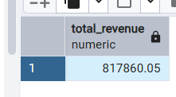

**Q2. Average Order Value**

SELECT CAST((SUM(total_price)/ COUNT(DISTINCT(order_id))) AS DECIMAL(10,2)) AS avg_order_value FROM final_table;

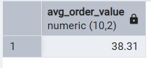

**Q3. Total Pizza Sold**

SELECT SUM(quantity) AS total_pizza_sold FROM final_table;

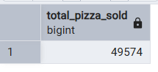

**Q4. Total Pizza Sold**

SELECT COUNT(DISTINCT(order_id)) AS total_pizza_sold FROM final_table;

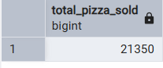

**Q5. Average Pizza Per order**

SELECT SUM(quantity)/COUNT(DISTINCT(order_id)) AS avg_pizza_per_order FROM final_table;

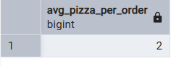

**Q6. Daily Trend for Total Orders**

SELECT TO_CHAR(order_date, 'FMDay') AS order_day,

COUNT(DISTINCT(order_id)) AS total_order

FROM final_table

GROUP BY TO_CHAR(order_date, 'FMDay')

ORDER BY total_order DESC;

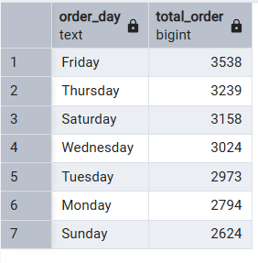

**Q7. Monthly Trend For Total orders**

SELECT TO_CHAR(order_date, 'FMMonth') AS order_month,

COUNT(DISTINCT(order_id)) AS total_order

FROM final_table

GROUP BY TO_CHAR(order_date, 'FMMonth')

ORDER BY total_order DESC;

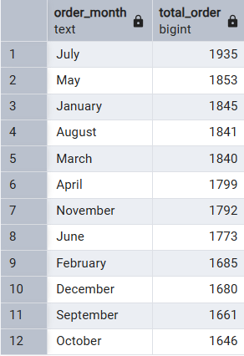

**Q8. % of Sales by Pizza Category**

SELECT pizza_category,

CAST((SUM(total_price)*100)/(SELECT SUM(total_price) FROM final_table) AS DECIMAL(10, 2)) AS pct FROM final_table

GROUP BY pizza_category

ORDER BY pct DESC;

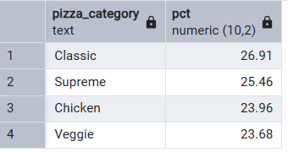

**Q9. % of Sales by Pizza Size**

SELECT pizza_size,

CAST((SUM(total_price)*100)/(SELECT SUM(total_price) FROM final_table) AS DECIMAL(10, 2)) AS pct

FROM final_table

GROUP BY pizza_size

ORDER BY pct DESC;

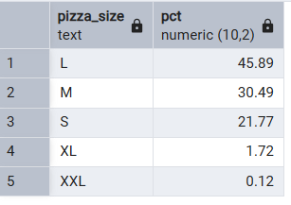

**Q10. Total Pizza Sold by Pizza Category**

SELECT pizza_category,

SUM(quantity) AS total_pizza_sold

FROM final_table

GROUP BY pizza_category

ORDER BY total_pizza_sold DESC;

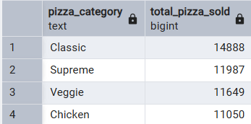

**Q11. Top 5 pizza By Revenue**

SELECT pizza_name,

SUM(total_price) AS total_revenue

FROM final_table

GROUP BY pizza_name

ORDER BY total_revenue DESC LIMIT 5;

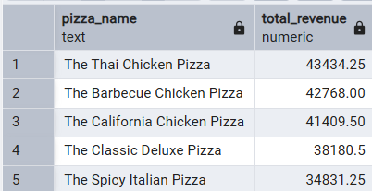

**Q12. Bottom 5 Pizza By Revenue**

SELECT pizza_name,

SUM(total_price) AS total_revenue

FROM final_table

GROUP BY pizza_name

ORDER BY total_revenue LIMIT 5;

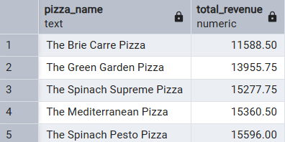

**Q13. Top 5 Pizza By Quantity**

SELECT pizza_name,

SUM(quantity) AS total_sales

FROM final_table

GROUP BY pizza_name

ORDER BY total_sales DESC LIMIT 5;

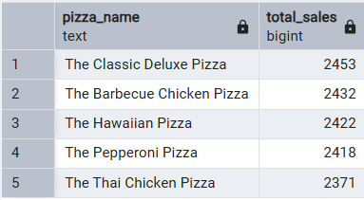

**Q14. Bottom 5 Pizza By Quantity**

SELECT pizza_name,

SUM(quantity) AS total_sales

FROM final_table

GROUP BY pizza_name

ORDER BY total_sales LIMIT 5;

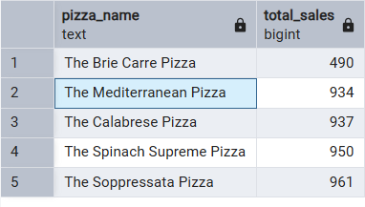

**Q15. Top 5 Pizzas By Total Orders**

SELECT pizza_name,

COUNT(DISTINCT(order_id)) AS total_orders

FROM final_table

GROUP BY pizza_name

ORDER BY total_orders DESC LIMIT 5;

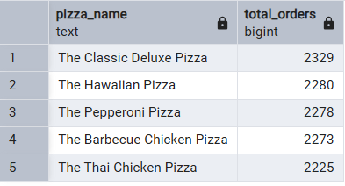

**Q16. Bottom 5 Pizzas By Total Orders**

SELECT pizza_name,

COUNT(DISTINCT(order_id)) AS total_orders

FROM final_table

GROUP BY pizza_name

ORDER BY total_orders LIMIT 5;

